**Name: Ole Elija Dziewas**

**Overarching question:** How sustainable was and will our use of satellites be?

1. How has the number or mass of satellites in space changed?

Screenshot of Tableau:

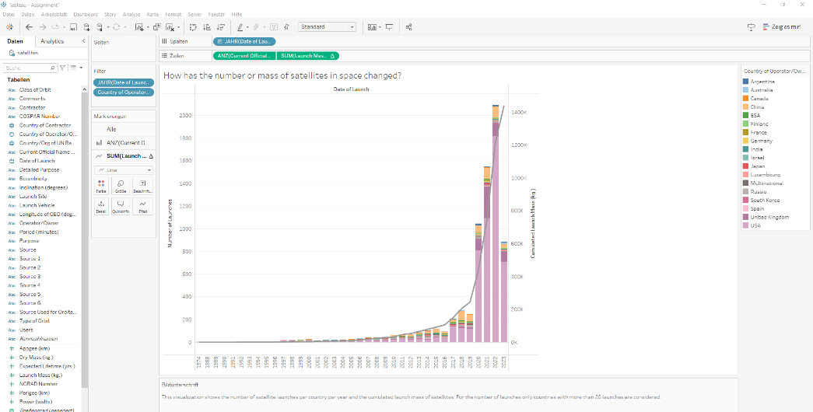

The actual visualization:

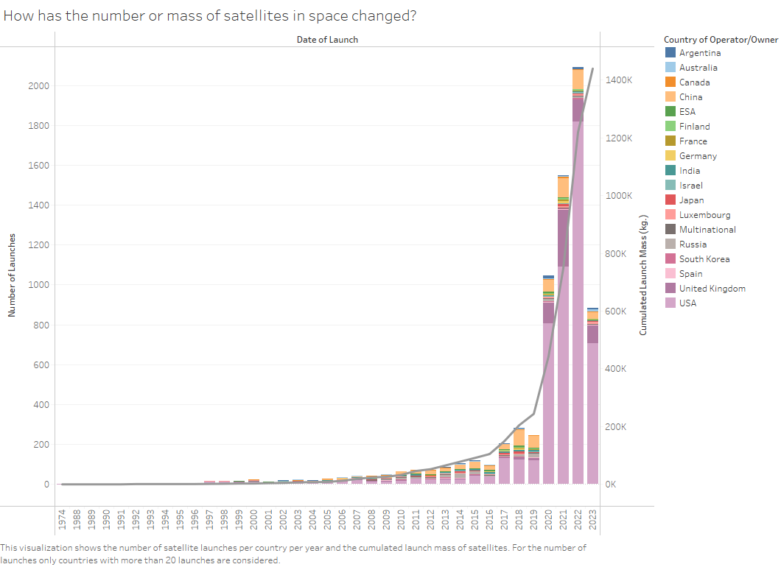

**Caption**: As to be seen in this visualization the number of satellites send to space per year increases exponentially. Even though 2023 has only about 900 recorded launches it is probably due to the fact, that the latest recorded launch in the dataset is from the 15.04.2023. The overall mass of human made objects in space increases also exponentially. This launch behaviour could lead to a fast pollution of space.

2. How has the lifespan and mass of satellites developed?

Screenshot of Tableau:

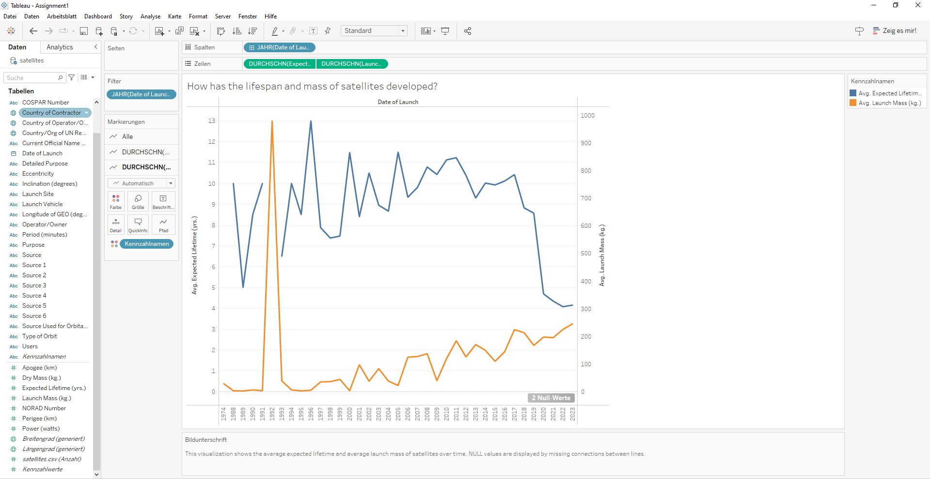

The actual visualization:

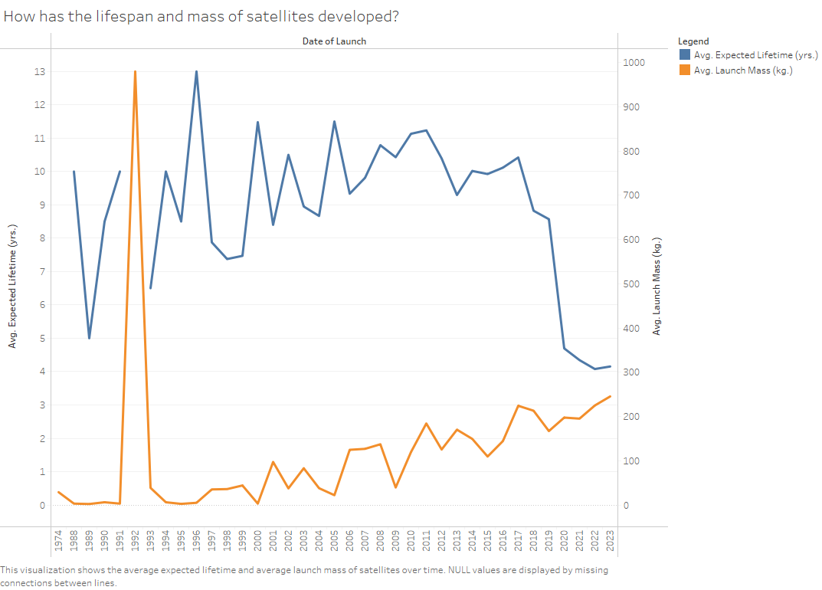

**Caption**: Despite great research advancements in the field of satellites and space transport the overall average life expectancy of a satellite decreases. Also the mass of a single satellite increases steadily. Without proper disposal mechanisms this could lead to a lot of useless junk floating around the earth.

3. What do we actually use satellites for and is this use itself justified?

Screenshot of Tableau:

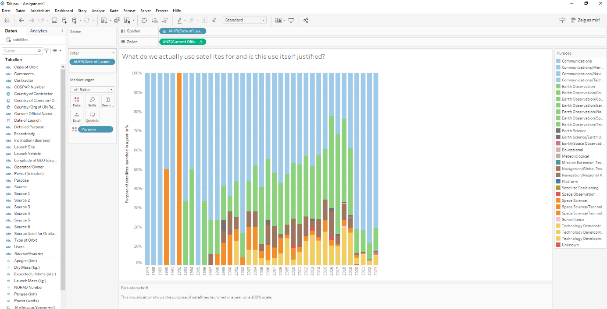

The actual visualization:

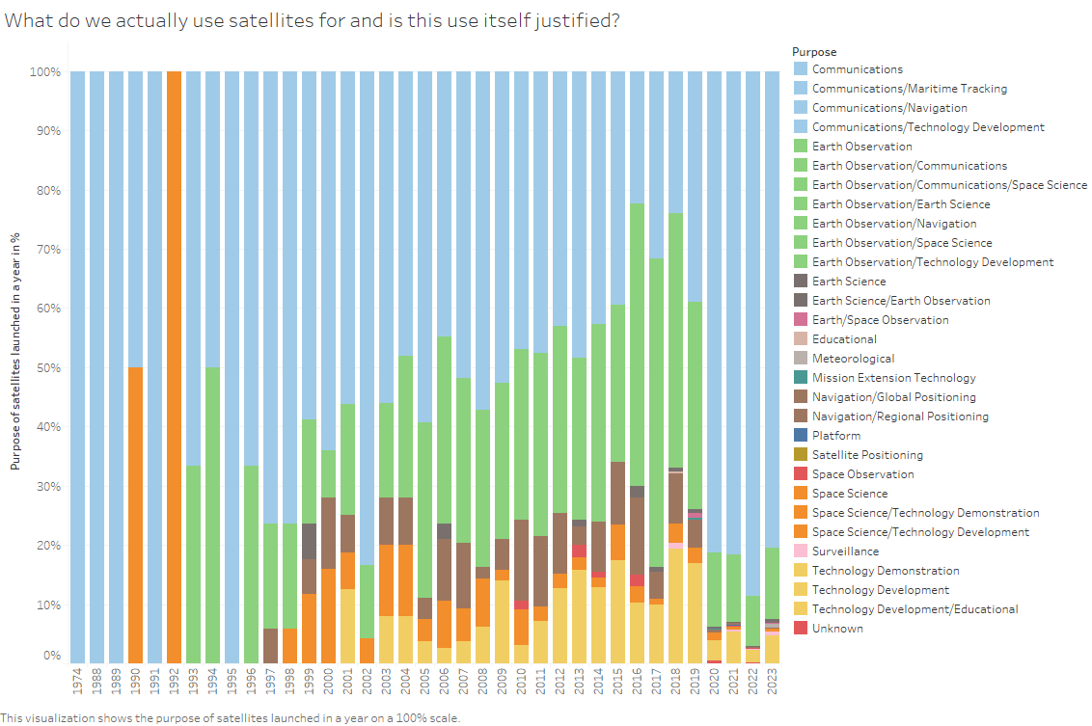

**Caption**: As to be seen in the visualization the biggest use case of satellites is communication. The most important other use cases are earth observation, space science, navigation and technology development. Even though communication is one of the key aspects of modern society, there should be the question, if there are not any better alternatives to satellites.

4. How well are the satellites distributed in space?

Screenshot of Tableau:

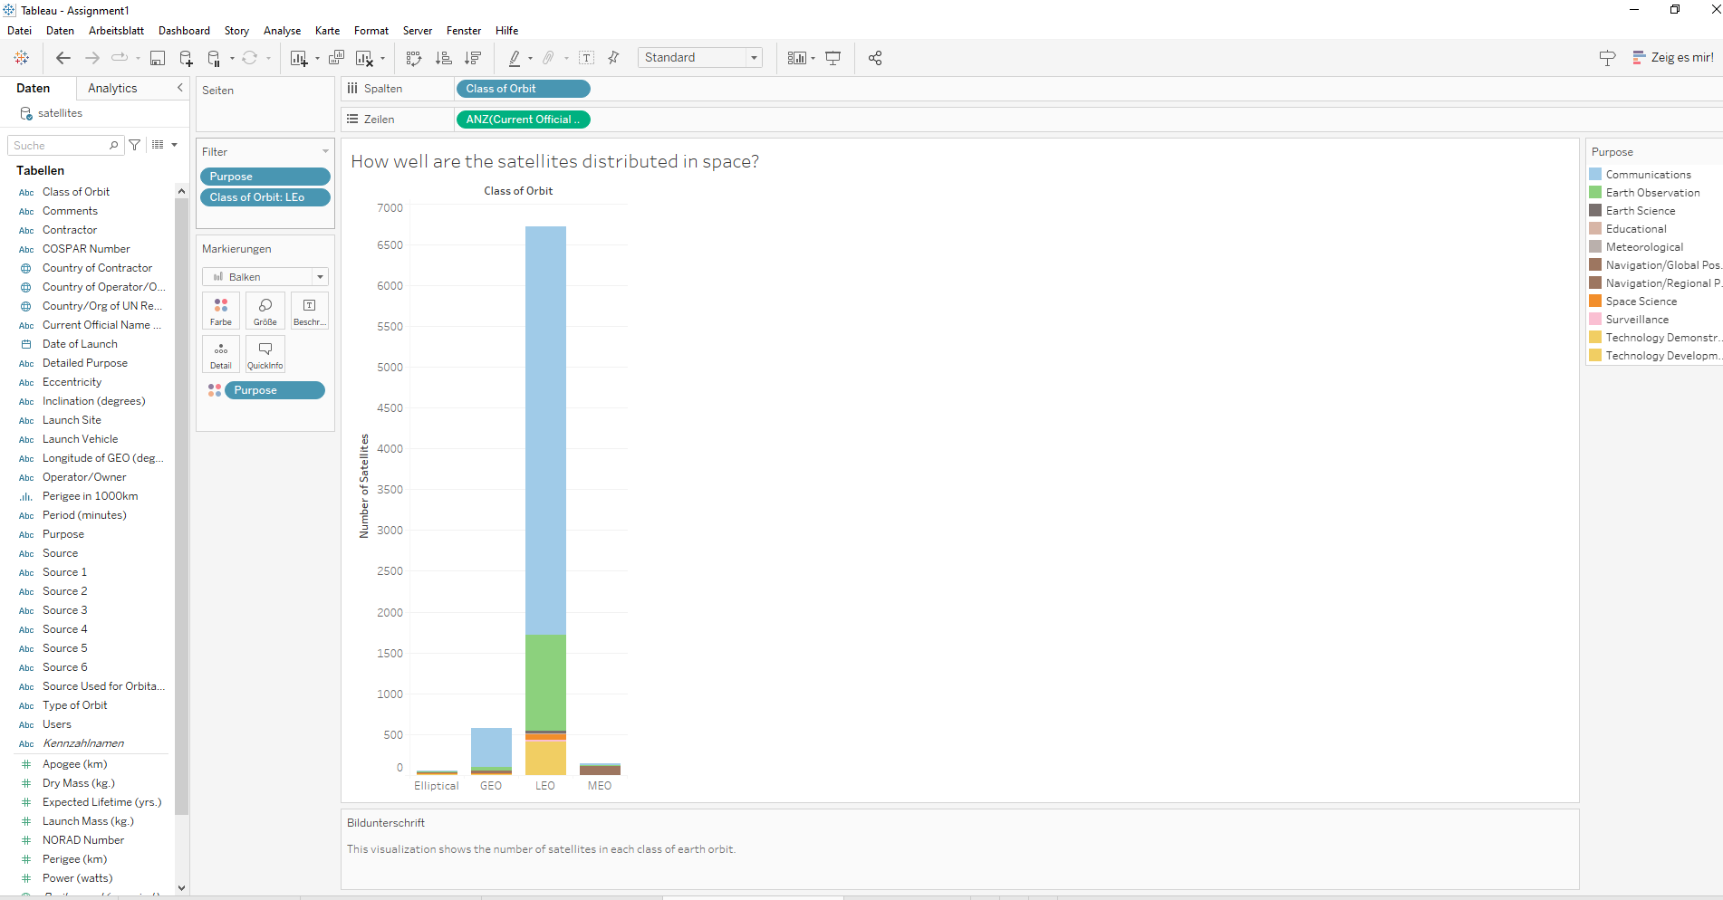

The actual visualization:

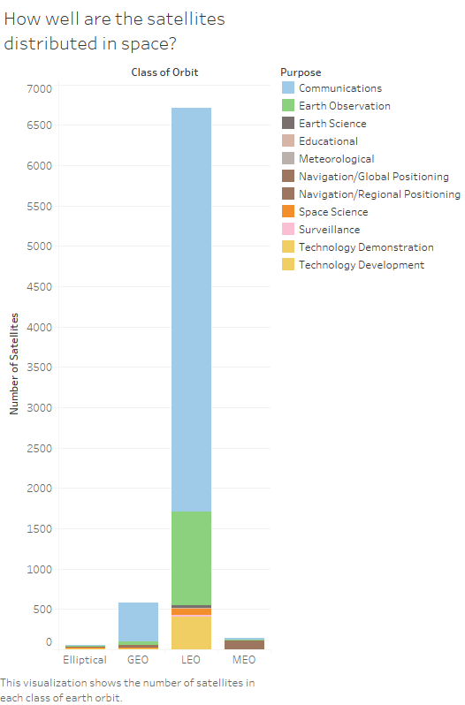

**Caption**: As to be seen in the visualization most of the satellites are in the Lower Earth Orbit (LEO) which is at height of 200 to 2000 km. Therefore, especially with the exponential grow of satellite launches in mind, there could be a huge density issue with a resulting risk of collisions.

5. Which country has the greatest influence on the sustainability of satellites?

Screenshot of Tableau:

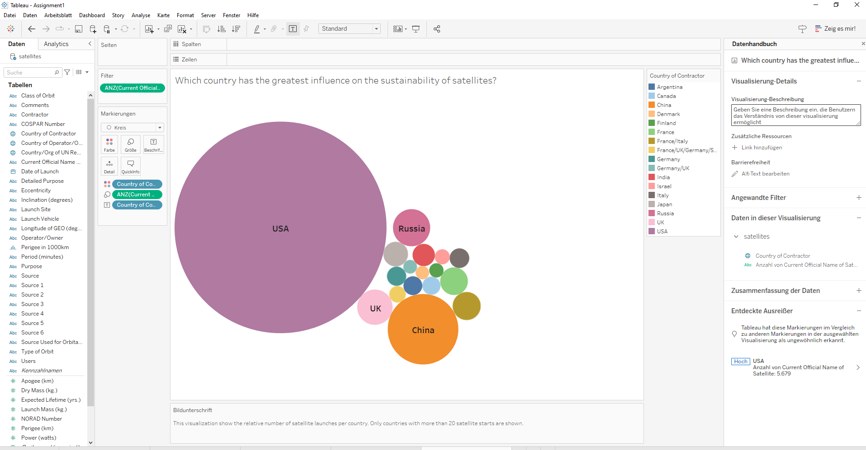

The actual visualization:

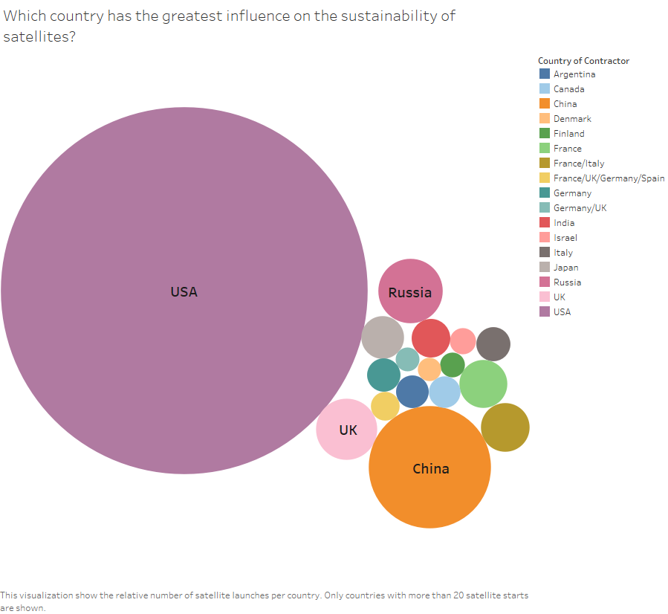

**Caption**: The by far most important country given the amount of satellites contracted are the USA. Even though China, Russia and UK are also important, the amount of satellites they have together is still less than the one of the USA. Therefore the development of a sustainable handling of satellites greatly depends on the USA.